Programming for Classification
The included Python file demonstrates the building and evaluation of a KNN, Naïve Bayes, and Decision Tree classifiers to predict the sentiment of a given sentence. The underlying dataset includes 3,000 sentences of reviews from Amazon, IMDB, and Yelp and a binary value indicating the sentence’s sentiment, where a 1 represents a positive sentiment and a 0 represents a negative sentiment. The program operates under a handful of assumptions, including that the sentiment of a sentence is strictly binary, and that each subset of the data is a representative sample of the entire dataset. In order to build the classifiers, the data was first stemmed using the Natural Language Toolkit package, and then the data was split into a training, validation, and test split, each subset making up of 60%, 20%, and 20% of the dataset, respectively. From there, the top 1024 most frequent words were kept, excluding commonly occurring words such as “is”, “but”, “an”, and others. The three classifiers were then initialized, including a KNN classifier that did not come from a previously existing package. Another function was introduced in order to easily evaluate the performance of each of the three classifiers. Performance was measured by Accuracy, Precision, Recall, Specificity, and AUROC. The individual metrics of each classifier can be seen in the table below, as well as the ROC curves.
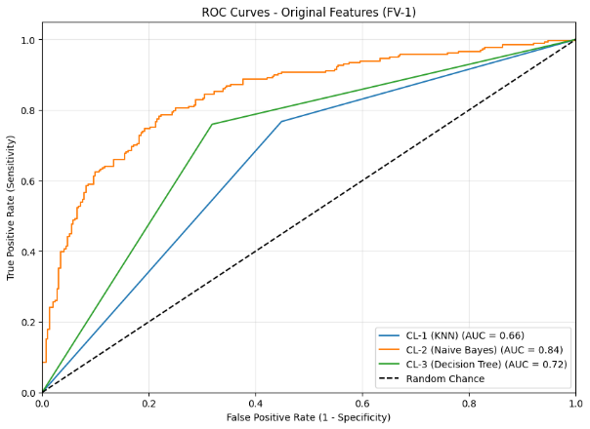
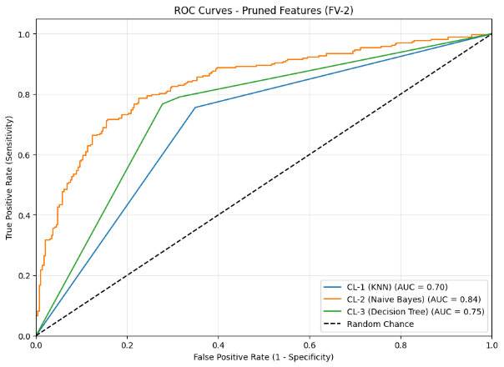
The results show that the feature selection approach, which limits the dataset to the 1024 most frequent words, improves efficiency while maintaining similar classification performance. The largest benefit appears in the KNN classifier. Its accuracy increases from 0.653 to 0.700, while the online prediction cost drops from 67.07 to 15.23. A large reduction is expected because KNN relies heavily on distance calculations, which become faster when fewer features are used. None of the other classifiers see a significant change in their efficiency costs between the two feature vectors. The Naïve Bayes classifier shows only small changes in accuracy, moving from 0.773 to 0.775, and a slight decrease in AUROC from 0.844 to 0.836, suggesting that Naïve Bayes is already well suited to higher-dimensional data and gains little from feature reduction. The Decision Tree classifier experiences a minor drop in accuracy from 0.735 to 0.729, which is reasonable since decision trees naturally perform their own feature selection during training. Across all classifiers, precision, recall, and specificity remain relatively stable. This indicates that reducing the feature space does not significantly harm the models’ ability to distinguish between classes.

